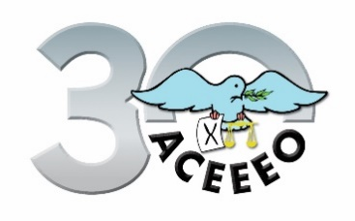
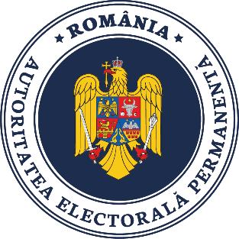

Concept paper

2021 is a milestone in the history of ACEEEO; this year we celebrate the 30th anniversary of our foundation. This year the Annual Conference will be centered around two themes: Youth Participation, on the one hand, and Campaign- and Party Finance, on the other.
First, ACEEEO celebrates by looking forward to the future of democracy and elections – to the youth. Today’s first voters will shape tomorrow’s democracy, it is therefore paramount to understand how the youth think, what attitudes they have, and how their meaningful engagement in the more formal democratic processes might be increased. ACEEEO has been devoted to this topic in the past and dedicates its activities in 2021 mostly to this theme.
The Conference approaches this complex topic from multiple angles, focusing, on more practical aspects, such as the role of key stakeholders (e.g., EMBs, international organizations and election officials) highlighting best practices in terms of voter education communications, youth engagement and involvement. For youth involvement to increase it is crucial to reflect on the gap of understanding and usage of media platforms that is often present between key stakeholders and first voters. Therefore, those involved in communication with the youth will discuss questions, such as what the most effective style and platform of communications are, or what the biggest challenges, most effective best practices are, what resources are needed to engage in an effective youth outreach campaign and how these resources might be procured. Furthermore, theoretical questions should be discussed as well, such as the role and justifiability of the constitutional framework (e.g. the age limit) and the general trends related to youth participation, such as the apparent divide between youth participation in activism, involvement in informal democratic processes and youth participation in elections, which has been highlighted by the emergence of globe-spanning youth movements.
The Conference’s background assumption is that speaking about the youth is only fruitful if the youth themselves are included in the discussion, therefore young speakers will present, and the event will offer an opportunity to exchange experiences with young voters.
Second, the Conference deals with the topic of campaign- and party finance. In the modern political contest money and politics cannot be disentangled. The question how political actors receive funds, how they spend it, and how they need to report it is of utmost importance in any democracy. The Conference focuses on the question of how money is spent during electoral campaigns, either from dedicated campaign fund or from the general resources available to parties.
The Conference approaches the topic from a regulatory perspective as well; one key question from a comparative angle is how campaign- and party finance are regulated. Political parties may use various funds ranging from state subventions to micro-donations, but it often differs from country to country that from whom and in what amount parties and candidates may receive money. There is no single way to regulate money and politics, however, there are good practices to borrow, historical failures to avoid, and important trade-offs to recognize.
Finally, a key aspect of campaign- and party finance is transparency. Different monitoring institutions, including state authorities and watchdogs from the civil society may help each other in protecting the integrity of the political process. Moreover, social media and the internet are both a challenge and an opportunity; they introduced new activities that should be regulated, however, they may also make the spending in the virtual space more transparent. These key stakeholders – state authorities, the civil society and companies – might learn from each other by exchanging best practices, as well as complement each other’s efforts, thus, providing equal opportunities in the competition and preventing malpractice.

